15. Simulation of Beam Steering in Antenna Arrays under Scan Angle, Frequency, Gain, Beam Width, and Sidelobe Suppression
Aim
To simulate beam steering in a phased antenna array by varying the scan angle, operating frequency, antenna gain, beam width, and sidelobe suppression, and analyze their effects on the radiation pattern.
Objective
- Study beam steering using phased array antennas.
- Analyze the effect of scan angle on the main beam direction.
- Observe how frequency affects antenna performance.
- Measure gain and beam width for different steering angles.
- Reduce sidelobe levels using amplitude tapering techniques.
Software Required
- MATLAB (Antenna Toolbox/Phased Array Toolbox)
- CST Microwave Studio (optional)
- HFSS (optional)
Components/Parameters
- Uniform Linear Array (ULA)
- Number of antenna elements: 8 or 16
- Operating frequency: 2–10 GHz
- Element spacing: λ/2
- Scan angle: -60° to +60°
Working Procedure
- Create a uniform linear antenna array.
- Set the operating frequency and element spacing.
- Apply progressive phase shifts to steer the beam.
- Change the scan angle and observe the radiation pattern.
- Measure antenna gain and beam width.
- Apply sidelobe suppression methods (Taylor, Chebyshev, or Hamming window).
- Compare results for different scan angles and frequencies.

Matlab code:

clc;
clear;
close all;

% Parameters
fc = 3e9; % Frequency (3 GHz)
c = 3e8; % Speed of light
lambda = c/fc; % Wavelength
N = 8; % Number of antenna elements
d = lambda/2; % Element spacing
theta = -90:0.1:90; % Observation angles
scan_angle = 30; % Beam steering angle (degrees)

k = 2*pi/lambda;

% Hamming window for sidelobe suppression
w = hamming(N);

% Array Factor Calculation
AF = zeros(size(theta));

for n = 1:N
phase = k*d*(n-1)*(sind(theta)-sind(scan_angle));
AF = AF + w(n)*exp(1j*phase);
end

AF = abs(AF);
AF = AF/max(AF);
AF_dB = 20*log10(AF);
AF_dB(AF_dB < -40) = -40;

% Plot Radiation Pattern
figure;
plot(theta, AF_dB,'b','LineWidth',2);
grid on;
xlabel('Angle (Degrees)');
ylabel('Normalized Gain (dB)');
title('Beam Steering with Sidelobe Suppression');
axis([-90 90 -40 0]);

% Maximum Gain
[maxGain, idx] = max(AF_dB);
beamDirection = theta(idx);

fprintf('Operating Frequency = %.2f GHz\n',fc/1e9);
fprintf('Scan Angle = %d degrees\n',scan_angle);
fprintf('Beam Direction = %.2f degrees\n',beamDirection);
fprintf('Maximum Gain = %.2f dB\n',maxGain);

% Beamwidth Calculation (-3 dB)
index = find(AF_dB >= (maxGain-3));
beamwidth = theta(index(end)) - theta(index(1));

fprintf('Approximate Beamwidth = %.2f degrees\n',beamwidth);

output:

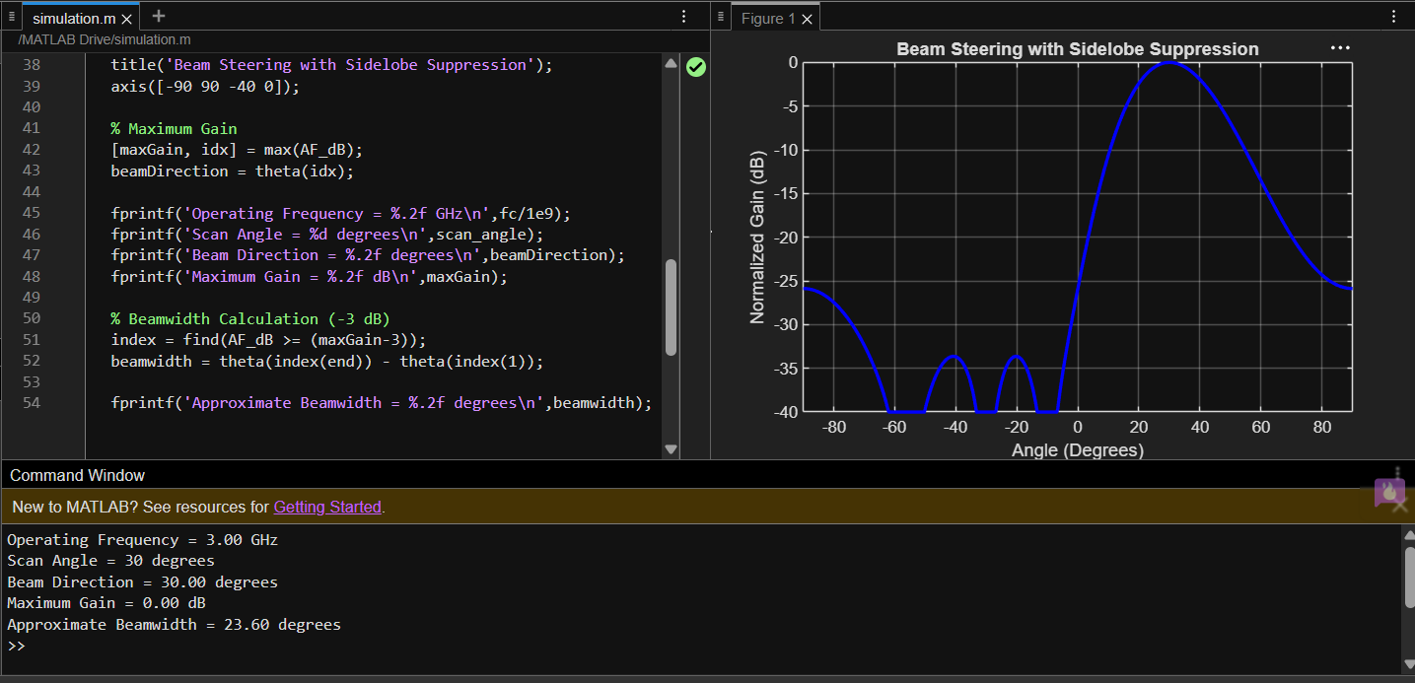

Expected Results
- The main beam moves according to the selected scan angle.
- Higher frequency provides a narrower beam width.
- Antenna gain changes slightly with steering angle.
- Sidelobe suppression reduces unwanted radiation while maintaining the main beam.
Applications
- 5G and 6G wireless communication
- Radar systems
- Satellite communication
- Military surveillance
- Smart antenna systems
- Autonomous vehicles
Advantages
- Electronic beam steering without moving the antenna.
- High antenna gain.
- Improved signal quality.
- Better interference rejection.
- Fast beam switching.
Limitations
- Increased hardware complexity.
- Higher implementation cost.
- Gain decreases at very large scan angles.
- Grating lobes may occur if element spacing is too large.
- Requires precise phase control.
Conclusion
Beam steering simulation demonstrates how phased array antennas can electronically direct radiation by adjusting phase shifts. The study shows that scan angle, frequency, gain, beam width, and sidelobe suppression significantly influence antenna performance, making phased arrays suitable for modern wireless, radar, and satellite communication systems.

